Macro-damage Behaviour of Al-6Mg Alloy Impacted by
A4 size (210 mm x 297 mm)：Top and Bottom：2.5 mm, Left and Right 2.8mm limited within 6 pages
Projectiles with Velocities of 1-7 km/s
16 pt overstriking

J. S. Zhou, L. Zhen, G. A. Li, D. Z. Yang

Harbin Institute of Technology

Harbin 150001, People's Republic of China
12 pt，(two character indented in the first line of a paragraph)
14 pt，overstriking
row spacing is 20

Abstract
Damage behaviors of a LF6 alloy under the impact of GCrl5 steel projectiles with velocities of 1~7 km/s have been studied. The results show that, craters formed in semi-infinite targets impacted by projectiles with lower velocities are a columned one with a hemispherical bottom. With increasing the impact velocity, the shape of craters changes into hemispherical gradually.
One row
Keywords:三到五个
Main text: 12pt，row spacing: 20
The same as the Abstract
- Introduction
Aluminum alloys are widely used as structural materials for airplanes and space vehicles, due to their lightweight, high specific strength and high specific modulus. During their application, aluminum alloy parts are likely to be impacted by strong load, for example, the collision of a flying bird with an airplane, the strong impact of meteoroids and space debris with space vehicles, etc. Early studies of damage behaviors of aluminum alloys caused by hypervelocity impacts are derived from the erosion of the space vehicles by hypervelocity meteoroids. With the rapid increase of activities for exploring the space by human being, large number of debris have been produced in the space[1-4].

- Experimental
The composition (wt.%) of the target material is Al-6Mg (LF6), and that of projectiles is Fe-l.0C-l.65Cr-0.4Mn-0.37Si (GCrl5). Physical and mechanical properties of the two alloys are shown in Table 1. The thickness of targets changes from l0 to 50 mm, and projectile diameters are 1 mm, 1.65 mm, 2 mm and 3 mm, respectively. Spherical GCrl5 steel projectiles were fired by an explosion accelerator with speeds of 1~ 7 km/s. After impacts, the diameter (D_{c}) and vo1ume (W_{c}) of craters were measured, and then specimens were spark cut just across the crater center, in order to measure the depth (P_{c}) of craters (see Fig. 1).

Table l Physical and mechanical properties of target and projectile materials
Materials | E  GPa | HB  MPa | ρ  g/cm³ | C_{v}  J/kg.°C | T_{m}  °C | α  x10⁻⁶°C⁻¹ | Poisson’s ratio  μ
LF6 | 70 | 850 | 2.64 | 921 | 660 | 22.8 | 0.337
GCr15 | 196 | 1900 | 7.85 | 473 | 1535 | 11.0 | 0.3
12 pt overstriking
row spacing: 20，
- Results and Discussion
3.1 Change of crater morphology and size with projectile velocities
The macro-damage on targets caused by hypervelocity impacts is a crater. The damage tapes change with the projectile velocity (ν₀) and the target thickness (δ). However, there is a common feature for craters in different conditions, that is, a projecting outer fringe is always observed in the “mouth” of craters, and the root of the fringe connects with the target, showing that the fringe is extruded from the crater. Figure 2 shows three typical damage formed in the LF6 aluminum alloy target under impacts. It is shown that the crater formed in semi-infinite targets impacted by projectiles with lower velocities (ν₀ = 1 km/s) is a columned one with a hemispherical bottom (Fig.2a). With increasing the impact velocity, the shape of craters changes into hemispherical type gradually, see Fig.2(b). Conical-shape craters are always formed in medium-thick targets, and obvious protuberance with cracks are observed on the back surface of targets, see Fig.2(c) which shows the crater formed in a l2 mm thick target impacted by a 4 km/s projectile.
Figures and tables should be placed as close to where they are referenced as possible. Please number figures and tables consecutively. Place the figure caption at the bottom of the figure and the table caption at the top table, using the template.Please place all figures directly into the text, not into the overlay. Do not use frame lines for figures.
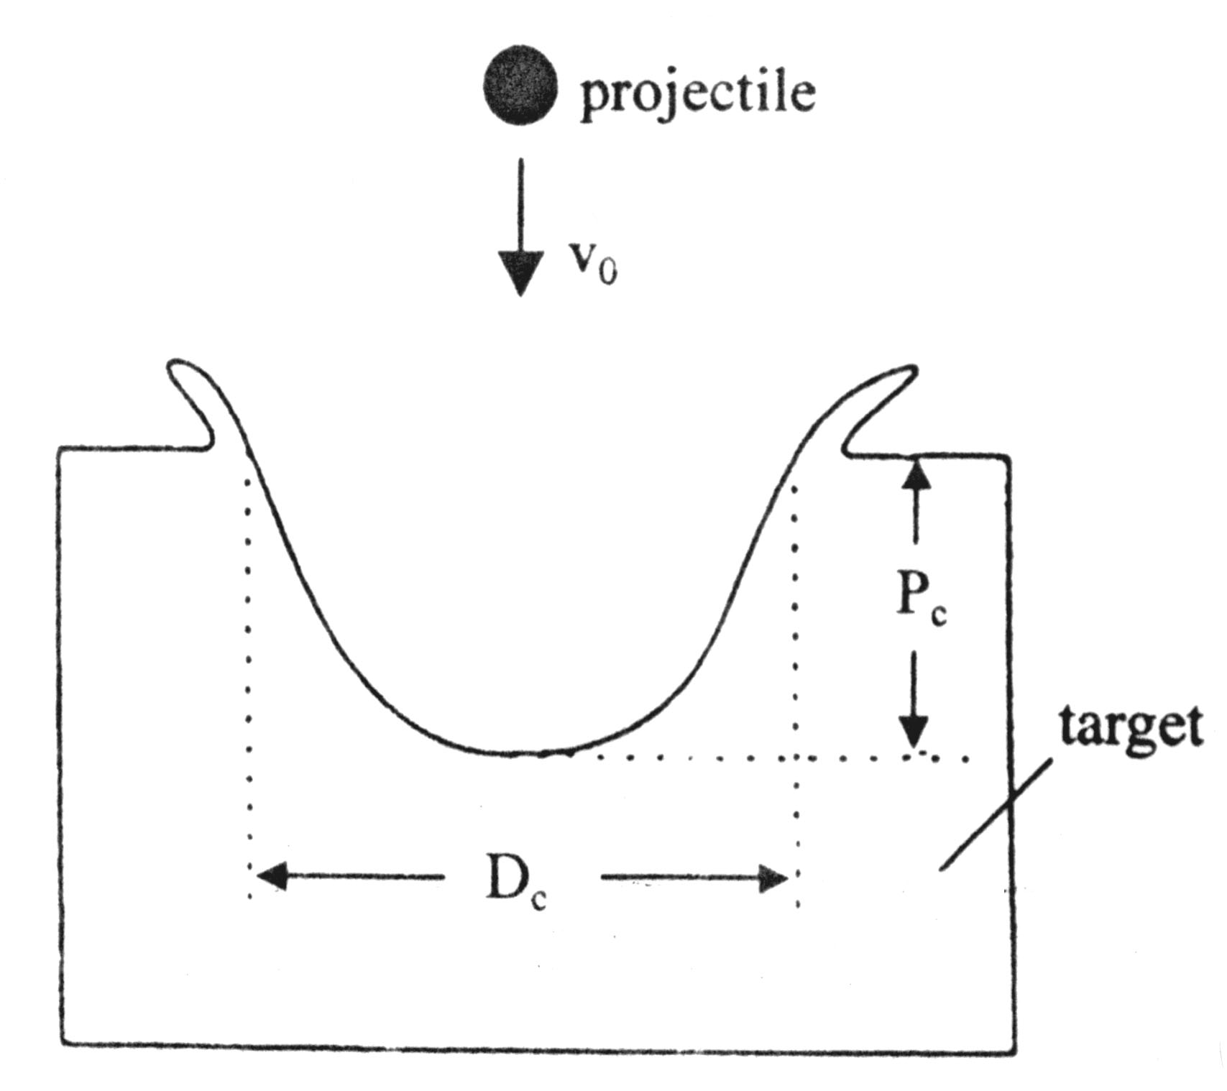
Fig.1 Definition of crater depth and diameter

3.2 Calculation of the pressure produced by hypervelocity impacts
Extremely high pressure is usually caused by the hypervelocity impact of a projectile into a target. The velocity and pressure of each constituent particles of both the projectile and target on the impact interface should be equal, in order to satisfy the continuity condition of the interface between the projectile and the target. The impact adiabatic curves of the projectile and the target can be expressed as:

- Conclusions
The morphology of craters formed in LF6 targets changes with the target thickness and the projectile velocity. With increasing the impact velocity, the crater formed in semi-infinite targets changes from the shape of a column with a hemispherical bottom into hemispherical shape gradually. Craters formed in medium-thick targets usually show conical shape with obvious spall phenomena.

References
- E.Potter Andrew. Measuring the Orbital Debris Population. Earth Space Review. 1995, 4:21~29.
- T.H. See, M.K. Allbrooks, et al. Meteoroid and Debris Impact Features Documented on the Long Duration Exposure Facility. NASA JSC Report # 24608, l990: 561.
- W. Flury. Space Debris Related Activites of ESA. USCOPUOS, S&T SC. February 1995.
- Laurnce, M.R., Brownlee, D.E. The flux of meteoroid and orbital debris striking satellites in low earth orbit. Nature, l986, 323: 136
- H.A. Zook. Deriving the velocity distribution of meteoroids from the measured meteoroid impact directionality on the various LDEF surface, in LDEF –69 Months in Space. First Post-Retrieval Symposium, NASA CP 3134, 1992: 569~580
As shown in the template:
Author For more than two authors it should be cited: Surname of the first author et al. The references should be located at the end of the text and they should be in numerical order and formatted as shown below.

- F. Vollertsen, H.A. Zook, et al. State of the art in micro forming. J. of Machine Tools and Manufacture. 2006, 46-11(1): 1172-1179.

